**ENGR 122 Homework 6**

**NOTE:** Use engineering format for problems 1-4. Use non-engineering format for problems 5-7. This is an individual assignment.

1. A boy who weighs 98lb is playing basketball on an outdoor basketball goal that uses weights set on its base to stay upright. If the boy hangs on the edge of the rim as shows, what is the minimum number of disk weights (20lb each), that must be placed on the base at point C to keep the goal from tipping over? 4 disk weights *NOTE: If the goal is unbalanced it will tip at point A.*

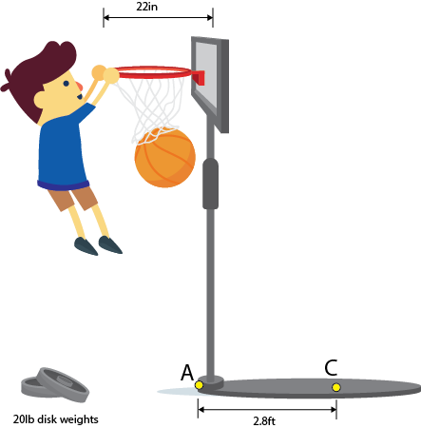

1. Gears are meshed as shown. Gears 2/3 and 4/5 are stacked (compound) gears. If the gears have the given number of teeth and gear 1 turns at a rate of 3600 RPM, what is the RPM of gear 6? N1 = 46, N2 = 14, N3 = 58, N4 = 20, N5 = 94, and N6 = 32 RPM6 = 100764.64 *Note: Gears are not drawn to scale.*

3.

• answer. CCW

Two gears are designed to mesh as shown.

Gear 1 is driven by another gear that

is not

shown which induces a force,

F

, equal to

52

N as shown. Gear 1 has

78

teeth

and a pitch diameter equal to 6

4

mm

.

If Gear 2 has

44

teeth

, and the gears

are to remain at constant speed while the tangent force F is applied,

find the

•

Value of the

resisting torque

that is

applied to Gear 2

.

0.939

N

-

m

Direction that the resisting torque should be applied.

Explain your

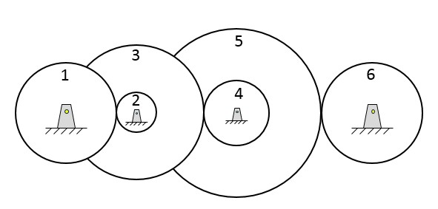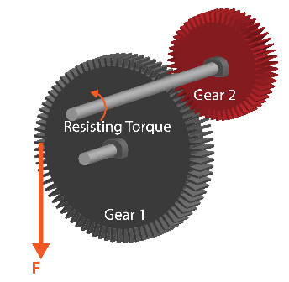

*Note: Gears are not drawn to scale.*

1. The max speed for the servo shown is 130RPM when connected to 6V. Assume that the gearbox on your servo is able to output a torque of 1.5 kg-cm while turning at this speed. Using the number of teeth on each gear provided in the table, determine the torque and rotational speed of the ***output shaft on the DC motor***. 30515.086 RPM and 0.0627 N-cm

|  |  |  |  |  |  |  |  |  |  |  |  |  |  |  |  |  |  |  |  |
| --- | --- | --- | --- | --- | --- | --- | --- | --- | --- | --- | --- | --- | --- | --- | --- | --- | --- | --- | --- |
|  | |  |  | | --- | --- | | **gear** | **# teeth** | | 1 | 10 | | 2 | 47 | | 3 | 10 | | 4 | 38 | | 5 | 8 | | 6 | 32 | | 7 | 7 | | 8 | 23 | |

*HINT: Work backwards from the output shaft and use the equations developed in class that relate the number of teeth to the torque. When working back from the output shaft to gear 7/6, realize that the “torque” transmitted by gear 7 is the SAME as the torque transmitted by gear 6 since they are joined. Then, relate the torque of gear 6 to gear 5 based on their numbers of teeth. Since gears 5 and 4 are actually one piece, the torque in 4 and 5 will be the same (as was the case for gears 6 and 7). Repeat for the other gears, working your way all the way back to the DC motor.*

1. A specific type of gear is an idler gear. Research online what an idler gear is, how to identify one, and how it influences the gear ratio of a gear train (specifically torque).

1. Review the list of sensors/devices that can be checked out for the ENGR 122 project. Choose one to research in more depth. Write a few sentences about how the sensor/device works. Include some potential applications for the sensor/device.

1. Add another idea to your “Idea Wallet.” You can use any of the idea prompts from previous homework assignments (listed below) or you can come up with something outside of the list. Please name the project idea, state who you talked to if you spoke with anyone about the idea, write up at least a two-sentence description of the idea, and provide pictures when it makes sense to do so. *You don’t need to try to find a solution to the problem at this point!*
   * something that bugs you
   * something that bugs someone else
   * something that could be fixed, improved, or developed through one of your hobbies, a sport, or a recreation activity
   * something that could be fixed, improved, or developed in a specific field of study (e.g., medicine, transportation, education, business, food, etc.)
   * something that could be fixed, improved, or developed in your community (Louisiana Tech, Ruston, or your hometown)